

Group ID – 13

The Jio-poly - what it means to hold almost all aspects of the world's largest market

Submitted to

Professor Madhumita Mazumdar

(STS HM216 Project)

Abstract

**In today’s world where the Indian telecommunication company Reliance Jio is dominating in almost all aspects, it’s important to explore both the arguments ‘for and against’. The report puts forward the positive impact due to the Jio revolution on society and how it helped every individual in their profession.**

**While exploring the features offered by Jio we got to know how people started adopting things they never used to like online Business on Facebook, Online Payments, etc. All these were a major attraction for big tech. giants and the also report explores some investments in great detail.**

**Jio’s announcement of introducing 5G was a great attraction. Jio’s 5G solution is dedicated to our Prime Minister’s vision of "ATMANIRBHAR BHARAT". Ambani’s response: “We’re going to do 5G. We’re the only network in the world that doesn’t have a single Chinese component.” was a major eye-catcher.**

**While doing research we also got to know many drawbacks due to the monopoly nature of Jio that had to be taken into consideration. And so we explored its negative impacts on society as well as on the other companies like VI, BSNL, and Airtel. The Airtel One Web deal is also explained that can be a worry for Jio in the future but along with that, it shows that how other companies are working hard to compete with Jio and to maintain a healthy competition in the society.**

**Group Members**

* Patel Krupal Sanjaykumar (201901406)
* Dave Hastin Shanker (201901225)
* Patel Akshat Hemantkumar (201901143)
* Patel Dhruv Pravinbhai (201901205)
* Lakshya Singh (201901248)
* Patel Rajkumar Kamleshbhai (201901306)
* Parmar Jaydip Rajeshbhai (201901160)
* Modi Ketul Bharatkumar (201901124)
* Richa Sharma (201901190)
* Parita Premji Makvana (201901236)
* Vadhel Sarthakkumar Shamjibhai (201901086)
* Ghelani Sparsh Nilesh (201901206)

**Introduction**

**Reliance Petroleum Limited - back bone of Jio**

Reliance Industries Limited (RIL) is India’s largest private sector company. It operates through the following businesses: Oil and Gas, Refining, Petrochemicals, Textile, Telecommunication.

RIL realized that there might be little scope for their growth in the refinery and petrochemical business which was by far the primary driver of the company’s revenue, due to climatic change, plastic pollution, world-changing from combustion engines to electric motors, and additional competition in Oil refinery the company had to make changes. While these threats were still a worry of the future, it started planning its entry into the telecom market for expanding their economic sources. And finally in 2016 with Jio’s launch, India saw a big digital change.

Jio was able to achieve this scale in such a short period because it invested more than $30 billion, the biggest private-sector investment in India’s history, to build a broadband network to cover the country, an investment that was financed largely through debt and cash reserves from the parent company’s oil and gas business. But as oil and gas prices cratered over the last year, the company faced increasing pressure from public markets to reduce its massive debt load. Raising money for Jio made sense since it was suddenly the most immediately monetizable part of Reliance.

**Beginning of the Digital Journey…  Jio Monopoly**

When Reliance was just trying to expand their economic sources with the help of Jio, an issue was brought up in front of TRAI (Telecom Regulatory Authority of India) about the discriminatory distribution of Bandwidth among rich and poor by other telecommunication companies. Jio saw this phase as an opportunity to dominate in the market since the TRAI penalized Airtel, Vodafone, and Idea and supported Jio. After the penalty not only their reputation was affected but their users were also getting attracted towards Jio. Jio was not discriminating between rich and poor and they were trying to bring new customers instead of attacking existing customers. After this, the features offered by Jio like free 4G internet, unlimited calls, and excellent network, which was never offered by any other Telecom companies before was a great attraction for Indians.

**This started the venture of Jio to monopolize the Indian telecom market. The starting phase was fruitful and advantageous not only for the company but for every individual that can be understood by the upcoming section.**

**How Reliance Jio Revolutionized The Telecomm Market?**

The data volumes have skyrocketed since Reliance Jio set a foot into the Telecomm market four years ago. Also, despite the humongous increase in the data volumes the tariff rates have been reduced by several times since Jio’s arrival into the market. According to Kotak Institutional Equities, the data volumes rose 4160% to 20.3 billion GB in the July-September period in 2019-20 compared to 2016-17. On a per-customer basis, the average data usage rose from 500MB per month in 2016 to 10.6GB per month in 2019.

As per TRAI’s data, the average revenue spent per user has fallen from Rs.127 per user in the 1st quarter of 2017 to Rs.60 in the 4th quarter of 2019. However, since the 4th quarter in 2019, the data rates have almost remained the same as TRAI announced Minimum bound for recharge plans that any company can charge.

This revolution was imminent based on the fact that Internet Penetration was about 27% in 2016. The Indian Market still holds a huge potential based on the fact that penetration was about 38% in 2019. However, Jio by giving free internet for 1st 6 months and many elusive data offers thereafter, Jio sped up the process many folds.

Jio did play a huge role in digitizing the Indian society as per the governments’ Digital India campaign. Because of it, it has been possible to avail of many of the services digitally and made our life easy. Moreover, the OTT platforms that are now considered as the major source of entertainment, have been able to set a foot in India due to cheap data plans.

**Consumers have been the absolute winners**

Two years since Reliance Jio launched its services on Sept 5, 2016, consumers have been the absolute winners, with tariffs hitting rock bottom (voice almost free), data consumption increasing multi-fold. But the price wars have meant that smaller telcos have exited the market and even big ones such as erstwhile no. 2 and 3 operators — Vodafone India and Idea Cellular — have had to merge to be competitive. ET takes a look at some fundamental changes in the sector since Jio’s launch…

● Mobile data consumption in the country up from 20 cr GB/month to nearly 370 cr GB/month.

● Cost of data down to less than Rs 15/GB from at least Rs 250/GB.

● India now no. 1 in data consumption compared with 155th before the Jio launch.

● Enhanced user base across all key social media platforms; Facebook, YouTube with an estimated 70 m additions in the 1st year of Jio’s launch.

● Almost all smartphones now shipped are 4G-VoLTE enabled.

●In 2 years, Jio has garnered over 215M users at June end; average data usage/subscriber/month is at 10.6 GB; average voice usage/sub/month at 744 minute.

With schools and colleges shutting across India, millions have been left without a classroom. In this light, to extend support to such students, JIO will partner with Microsoft to provide facilities to help schools and colleges function digitally. Their broad bandwidth and digital capabilities will help support both healthcare and educational institutions.

With most people working from home, internet services in the country are finding it challenging to keep up with service requests. To help such people, Jio has announced that they will provide the basic JioFiber connectivity at 10 Mbps, to whoever needs it, free of cost. The only requirement being that the area in consideration has enough range for their services.

Furthermore, Jio has also said that it will provide routers to people with a bare minimum refundable deposit. Also, existing users will have access to double the data limit they now have, and the same offer will hold for Jio 4G data vouchers. This move will significantly help the students all over the country who are now turning to online learning platforms for their educational needs.

Reliance Jio is India’s first LTE-only network. LTE refers to Long Term Evolution of telecom technology that enables high definition voice and high-speed internet access.

LTE (Long Term Evolution) is the project name given to the development of a high-performance air interface for cellular mobile communication systems. It is the last step toward the 4th generation (4G) of radio technologies designed to increase the capacity and speed of mobile telephone networks.

Since the customers pay only for data in Jio, the voice calls are also made available by the feature called Voice over LTE. The feature is relatively new in the country, but it promises excellent audio quality which will be far better than our normal voice calls.

No additional charges for video calls. Reliance Jio spreading 4G network across India, we can see how people used and still using the internet even in villages. We have seen how students are using Jio to enhance their skills by watching videos on YouTube. By 4G network, you can watch videos without any further delay, you can open any file easily if you’re planning to research about any topic.

**JioFiber and its effects on the market**

* Reliance Industries is looking to **disrupt**the market again. And this time it is the launch of Jio Fiber. Jio Fiber is a**fixed-line broadband service**with many free services attached to it.
* Aiming to accelerate the **digital transformation** in India, Reliance Jio and Microsoft have entered into a 10-year partnership. This collaboration between the two companies will allow them to use their **potential**to give a comprehensive set of solutions incorporating connectivity, computing, storage solutions, and other technology services and applications necessary for businesses in the country.

* The pricing scale and style of Reliance Jio's fiber-to-the-home (FTTH) services, [Jio Fiber](https://www.livemint.com/Search/Link/Keyword/jio%20fiber), will expand the market and increase the scope for all operators to grow, including Airtel, since the home broadband penetration in India is well below 10 percent, according to analysts.
* India is estimated to reach 1 billion internet users by 2025.

|  |  |
| --- | --- |
| Year | No. Of internet users(in million) |
| 2015 | 302.36 |
| 2016 | 342.65 |
| 2017 | 422.2 |
| 2018 | 493.96 |
| 2019 | 636.73 |

|  |  |
| --- | --- |
| 2020 | 696.77 |

**Reliance Jio TV in agreement with Haryana Government to educate students**

Amid the COVID pandemic, the Haryana government has entered into agreement with Reliance Jio TV to educate government and private school students under the ‘Distance Education Programme’. Students will be able to watch all four channels of EDUSET through TV, laptop, desktop, tablet, and mobile. The aired content will be available on JIO-TV for a week for future reference. With 94 Lakh. Subscribers of Jio in Haryana it will be easily accessible.

**How Jio Became the Darling of Silicon Valley**

In the last 6-7 months the entire world has been suffering from the pandemic, But the Jio is in its way in which it had broken the record of foreign investments in this time period. The digital monopoly that is one of the world’s largest conglomerates, tech giant Facebook and Google was investing $4.5 billion, private equity firms like Silver Lake and KKR and strategic investors like Intel and Qualcomm. In a matter of just four months, Jio had raised some $20 billion from external investors.

Why this kind of interest Jio has received from American tech firms and investors and the **one reason** is **Anti-China sentiments**. When US President Donald Trump visited the country in early-March, during a discussion with chief executive officers of large Indian companies, **Trump asked Ambani** “You’re doing 4G. Are you going to do 5G too?” **Ambani’s** response: “We’re going to do 5G. We’re the only network in the world that **doesn’t have a single** **Chinese component.**”

And the **second reason** is that for investors who want exposure to India’s untapped potential in the hope that it will bloom, what better investment vehicle could there be than Jio? Facebook, for example, has more active users in India than any other country, and it still has scope to grow, on the other side Jio is the leading telecom company in India. Reliance’s reach and core infrastructure, make it — on paper — a great partner to Facebook. Google expands the market for Android smartphones in India. Chipmakers Intel and Qualcomm, who have a smaller stake in Jio, hope to have a role to play in Jio’s 5G strategy.

So, in upcoming days more benefits, more digital platform facilities to not only the Jio consumers but also to other telecom provider consumers due to competition to stay in the market. And many benefits of foreign investments will be there but with this, there are some questions raised which directly affect the concerns related to **national security.**

Every time investment in Jio was announced over the last couple of months, reporters, especially at foreign publications, made a pointed **note of** **Reliance’s closeness with the current government**. While the **CEOs of Facebook, Google, Amazon, and Apple** were hauled in front of the U.S. Congress for antitrust hearings, Reliance has worked hard to cultivate **deep ties with the government** at the state and national levels.

**Why Jio is our best option to bring new technologies to India.**

* **Huge money for investment**.
* Reliance's initial investment in Jio was Rs 150000. - Mukesh Ambani. So it is more likely that RIL will again invest huge amount in new technology.
* So as we can see net worth of Reliance industries increased exponentially in last 5-6 years after the establishment of Jio.

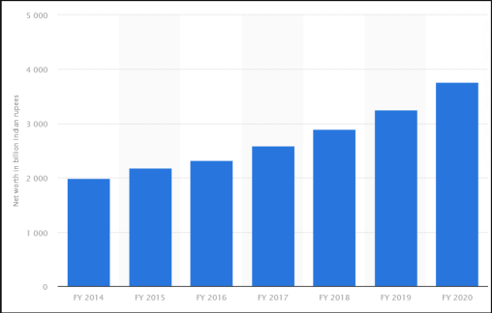

* **Have investment from big international Tech companies.**
* Big tech companies like Facebook, Google and Qualcomm invested in Jio.
* Qualcomm and Jio achieves over 1GB speed in trails.
* Google and Jio are working together on an Android-based operating system, and are even working to build an entry-level affordable smartphone that can take Indians off 2G and onto faster networks.
* Facebook and Jio will bring thousands of small businesses onto WhatsApp. - Mark Zuckerberg
* **Jio have the best strategy to cover every section of costumers**.

The way Jio made 4G network available and affordable, Jio is the best option to make new technology affordable.

**How Investments into Jio became a stampede**

Whenever we ponder about investments one thing we get to know is that for a strong partnership to persist it’s important to have almost the same goals/vision. Investors are always looking for a company that can help them to achieve their goals and in the end, benefits both. In this pandemic where other companies are trying to survive in the market, Jio is touching the sky because of the [series of investments](https://www.counterpointresearch.com/deep-dive-will-facebook-recoup-us5-7-billion-investment-reliance-jio/)cum partnerships from the biggest technology companies and investors.

If we look into the investment of Google of $4.5B from the #GoogleForIndia Digitization fund with Jio we get to know that the common goal plays a crucial role. The Motive of #GoogleForIndia is “Everyone should have access to the internet” and to solve the biggest challenges our country faces like education, jobs, and payments.

Google knows that in order to achieve these goals they should have a telecommunications company that already has billions of happy users and that provides internet services in almost all parts of India be it a rural or an urban area and who better than Jio can stand up to this. An important vision of “Digital Village” by Google is only possible if internet access to rural areas is strong and Jio is successful in doing this. It’s not that other companies can’t do but if we look into the cost then for a villager or a middle-class person Jio’s prices are feasible compared to other companies like ‘Idea’.

Features of Google like

* Google assistant speaking (searching in 9 different languages).
* “Internet Saathi” for women in rural areas.
* Google AI – Disaster management.
* Credible information on COVID.
* Google Pay.

are worthless if there is no cheap and easy access to the internet.

Sundar Pichai’s dreams can now be accomplished by the investment in Jio which is not only an advantage to Jio but an advantage to the society also as the motive of #GoogleForIndia is for the betterment of India’s small to big merchants, village woman’s, Children’s, Young generation, Health staff etc.

If we go back to the time when Jio 4G was just introduced because of its strong networks, activities on Facebook were highly increased. Not only new interactions were made but it helped small businesses to explore, house wife’s to explore their skills etc. At that time the online business was not a famous topic but soon with easy internet access people started businesses over Facebook and WhatsApp through online payments.

Jio and Facebook saw these as an advantageous growth in the future and so we have now the investment of Facebook of $5.7 billion in Jio Platforms Limited. One can see the investment fruitful for powering the recent introduction of JioMart across India. Every day millions of products are listed on [Facebook/Instagram pages](https://www.counterpointresearch.com/facebook-needs-bet-big-instagram-payments-monetization-opportunities-ahead/). This is an advantage to the small merchants or shopkeepers who wants to keep their businesses on track in this corona period and also for buyers who are afraid of offline shopping in this pandemic.

Facebook and Jio will try to leverage each other’s users. Facebook with the help of its user’s interaction will help to expand the JioMart and Payment Platform using Jio internet access which will, in turn, benefit them as well as society.

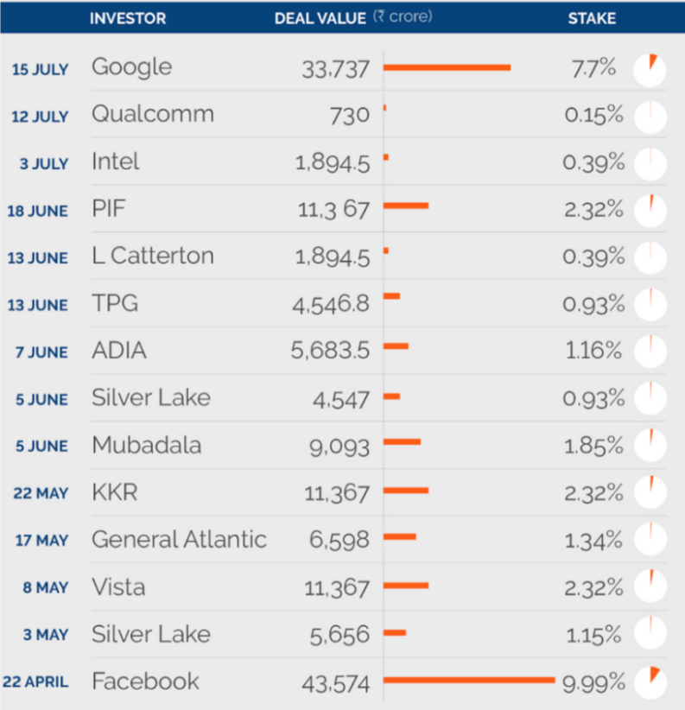

But looking at this there’s always a question in my mind - whether Jio would have been able to do all these without being a monopoly? And what I feel is without being a monopoly it would have been difficult for Jio or any other company/startups to do this. Because Monopoly gives a sense of ‘trust’ to partners which are often unbreakable. No matter Google is investing in other companies also but Jio is gaining more profits due to its monopoly which is good for them but along with that, it’s better for our country’s growth also. If Jio would not have been such a strong operator no such big companies would have ever thought of investing such a big amount in India’s economic or social growth.

**Future with 5G**

As per the virtual AGM of Reliance Industries Limited; 43th Annual General Meeting, Reliance’s Chairman pointed that Jio has created a complete 5G solution from scratch, that will enable us to launch a world-class 5G service in India, using 100% home grown technologies & solutions. Jio has taken step toward building Make in India-5G network, which will be ready for field deployment in 2021. Jio 5G solution is dedicated to our Prime Minister Shri Narendra Modi's vision of "ATMANIRBHAR BHARAT". Jio platform will also export 5G to other operators globally.

* When, 4G was launched it’s an average latency of around 45 milliseconds. And when, we see about 5G latency it’s an average latency of approximately 1 millisecond. Latency is basically showing response time. And, using 5G network technology we can get quick response and no delay ever. Using with low latency and high-speed data networks of 5G networks India can make dream true. Like, In Autonomous cars, Remote surgery (tele-surgery), connections of more and more IOT (Internet of Things) devices in daily lifestyle, high resolution VR (Virtual Reality) experience. We also can start to make smart cities in India. That would be proud for Indians.
* An autonomous car are capable vehicles which can sense its environment by own and they can operate without human present. This technology is still not available in India, because of many reasons like 4G network’s slow data speed and higher latency are major issue. After, launch of 5G networks using 100 times faster data speed networks and approximately 1 millisecond low latency (quick response) we could be definitely get success on Autonomous cars, buses and other vehicles without accident issue. Also, we can start/stop, lock/unlock basically operate our cars using 5G smartphones without any delay.
* Now, about Remote surgery (tele-surgery) is more beneficial for patients. Doctors can perform surgery on a patient without present at that operation location with patient. With the help of 5G’s fastest data speed network and using low latency property, there will be approximately negligible error happen at that operation with patients. Doctors can perform surgery from another country to our country and vice-versa.
* We can enhance our video quality of streaming, broadcasting to 4K without any buffer and VR (Virtual Reality) experience, we can enjoy our content from OTT platform and live stream in high-resolution. Also, we can get quick response time (no delay) and best experience in Gaming with 5G fastest network technology. Because of, 5G network technology cloud gaming’s experience must be enhance.
* Autonomous cars/buses/transport, remote surgery, broadband experience everywhere anytime, IoT devices, Artificial intelligence etc. should be turn normal city to ‘Smart city’. India’s Smart city dream project would be occurred by using Make-in-India, china-proof 5G network technology which was firstly introduce by Reliance Jio in India.

**Positive Impact on Other Small Companies**

* Jio provides many employment opportunities in our country.
* Jio aims to offer next generation of services such as Artificial Intelligence (AI), Virtual Reality (VR), and Robotic through high speed data networks. This shows that job opportunities will increase.
* The company has partnerships with around 6,000 colleges across the country, including technical institutions. These colleges offers certain courses that make students ready to work for Reliance.
* Company can also hire through referrals and now with the help of social media platforms. Adding college and employees ‘referrals’ are the two major contributors to their hiring plans.
* As we see the market cap of reliance is highest as compare to rest of the companies (14.72 lakh core). It means that RIL give good competition to other companies. Which can help other companies to work hard to compete with Reliance.
* This type of business mind can help other small companies to get motivations and can earn profits in any conditions.
* Reliance Jio partners with USP studios strengthening its kid’s content play. Through this partnership with USP studios, Jio users will now have access to 8 exciting edutainment aap including Kids First, Kids TV India, Junior Squad Kid Songs, Top Nursery Rhymes.
* Reliance now becoming an Omni-channel platforms, through which JioMart will integrate suppliers, consumers for digital fulfilment and payments.
* Reliance Retail is serving over 200 cities during the COVID-19 time, with the grocery platform crossing 250,000 orders a day.

**How Reliance Industries cleared its debt**

* The major chunk of the money to clear debt came from selling stakes in RIL’s young telecom and internet venture, Jio Platforms. In total, RIL has sold off a 24.7% stake in Jio Platforms through what it says is**“**the largest uninterrupted fundraising by a company anywhere in the world.”
* RIL raised Rs 53,124.20 crore from a rights issue, the first in three decades by the company. British oil and gas major, BP, also helped RIL clear its debt.
* Movie fans who would prefer to avoid a crowded theatre, are ready for same-day-release on the Jio platform.
* Change in the world business dynamics after coronavirus pandemic and an ongoing crude price war between Saudi Arabia and Russia may impact Mukesh Ambani's plan to make Reliance Industries (RIL), India's most profitable company, a zero net debt company by March 2021. As per the plan, RIL will have to conclude three major deals - Rs 1.1 lakh crore deal with Saudi Aramco, Rs 7,000 crore deal with BP Plc, and stake sale in Reliance Jio's tower infrastructure investment trust (InvIT) - within one year to cut the net debt of Rs 1.5 lakh crore to zero.

**After going through various positive impacts due to Jio on society there are various drawbacks that needs to be considered by meticulous observations. Upcoming section is about some of its negative impacts.**

**No competition with Jio**

In any country and any market, a Monopoly is the least of situations that are favorable to the consumers. When Jio stormed into the Market there were 4 telecom operators. VI (Vodafone Idea) and BSNL are on life support whereas Airtel is under large debt. With around 400 million present subscribers and one of the best services offered will only strengthen Jio’s position in the Market. A fresh inflow of 1.18L crore rupees for 25.09% stake in Jio from 11 global investors will worsen the situation more.

With all the new adventures of Jio and many more, not only Jio is trying to monopolize the telecom market but also it is intending to take multiple markets backed by the highest value company in India, Reliance Industries Limited (RIL). In a monopoly, there is no competition and so only one market entity can control the prices, controls the quality of the services and goods, and controls the market.

Is it that in Monopoly only one company will reap the benefits of the market while all other companies will have to incur a loss?

Well, it is not exactly like that. The situation is that all the companies that help the monopolistic firm in providing services will also reap the benefit. So, in order to make a profit, only the firms have no choice but to partner with the monopolistic firm and the consumer too do not have any choice but to use the services of a single monopolistic firm. Thus, monopoly is not healthy for the market as well as consumers due to lack of choices.

Moreover, if Jio is to become a Monopoly then as stated above it would control a lot of aspects of consumers and not only the telecom aspect. Thus, the number of companies that reap the benefits of the consumer market becomes even less.

**Flip side of 5G**

**As Jio is rushing towards the era of 5G it’s becoming a matter of concern not only for other companies but also for some individuals. Despite its tremendous advantages, there are some pitfalls that needs to be considered. According to TRAI reports, since 5G capabilities depends on hyper-dense networks, small cells will be required to be deployed at every 200-250 meters on many types of infrastructure such as electric utility poles, street light poles, bus stands, rooftops, traditional cell towers, etc.**

**The aim of Jio by collaborating with QUALCOMM or GOOGLE is definitely to give internet access to rural areas. But if we look at its negative side, whenever one thinks about a village/rural area, a beautiful image comes into one’s mind where we are isolated from any harmful radiations. But after the 4G revolution, if we go and see the village children, they too are addicted to smartphones.**

**This is just 4G but if we think of a future where 5G is available everywhere in the villages too then the villagers who were known for their good health and immunity would be now prone to diseases like cancer. Have we ever heard of a cancer case in villages before? I guess never. In India, there has always been a public concern on possible adverse health effects due to Electro-Magnetic Field (EMF) Radiation from mobile towers. Due to these people oppose the erection of telecom towers on rooftops of houses and in densely populated areas.**

**According to TRAI reports, it would be easier for a company like Jio to establish a 5G network across India than other companies because they already have their mobile towers widely spread across India and also millions of Jio users. Again this is a drawback to other companies who are still struggling to fight with Jio Monopoly due to its 4G revolution and now comes another wave of struggle if Jio in collaboration with google introduces 5G smartphones. Google is also aiming to take the affordable smartphones and services developed out of its partnership with Jio to the rest of the world. Analysts said Jio may well end up launching the cheapest operator-bundled 5G device worldwide.**

**So at last we can say that though 5G is very helpful there are many areas where it may turn out to be devastating if not used with care. It’s better to have other alternatives which are environment friendly too and other companies suffering from losses should try to compete with Jio ( like Airtel is doing ) even if it’s a monopoly, then only the society would have a healthy competition which would be better for our future generations to come.**

**Is Jio monopoly threat to our privacy?**

Mukesh Ambani in a recent speech told that data is the new oil and intelligence is the new petrol. Does it mean that Jio uses our data to their advantage?

**Why Jio needs users Data?**

Jio recently collaborated with Facebook and Google, who needs data for advertising and e-commerce. Reliance also has services that need user data. List of

Reliance service which needs Data: Reliance fresh, Reliance SMART, Reliance Market, Reliance digital, TRENDS, and many more digital Services like Jio TV and cinema. Reliance is also partnered with other retail stores.

So, Jio will use our data for digital marketing and improve their services.

**How Jio can steal our Data?**

Jio has lots of services in the market. Jio can track the user’s **location**through Jio Sim. Jio will know about our **daily purchases** if we buy it from JioMart. Jio will know about our **interests** and **likes** from their digital service. By collaborating with Facebook Jio can use WhatsApp's **commerce** for their own advantage. Jio can know our **search history** from Jio browser or if the user usesJio’s internet. If in the future if the user uses Jio Glass then Jio can get very crucial information easily. Jio is also making their smartphones which makes them use our **offline data** too.

**Why it is a threat?**

**First**, it is a threat to users. If in the future if data leaked it can cause big trouble for users.

**Second**, it is a threat to small businesses. If Jio dominates the market, it will affect digital advertising. Small businesses cannot compete in the advertisement. Jio will have complete control of the market.

Let’s take one case in which a person wants to buy a new laptop, so he searches for laptops on Jio browser or using Jio internet. So Jio will know that the person is looking for a new laptop. So Jio uses a person’s location and sends his mobile number to the nearest Reliance Digital Store. Now, the person will receive a call or message from the Reliance store in 1-2 days. Jio will also control a person’s ads. The probability of buying a laptop from Reliance Store will increase. In this way, Jio can play with your data for their benefit.

**Complete Dependence on Jio**

● Complete dependence on something is like the end of the “Competition Era”.

● After playing the “Free Data Network**”** game in the very 1st year of Jio, Jio got a large consumer market in comparatively little duration, they made almost all their consumers totally dependent on them for the data network. This was the first but not least instance of ‘Complete Dependence on Jio’. At the correct time, they started to charge for the same data network which was earlier free of cost. Not only these, but even they continued their same strategy in the other services also. Some of them as follows:

● As of now, IPL live stream is free on Jio TV, while other platforms charging for these. So, whoever is not able to pay for that but still wants to access it there is only one option. On Hotstar there is also free subscriptions to Jio consumers. **J**ioMeet, JioCinema, and lot more “Free but Strategic**”** schemes are there for making consumers totally dependent on them. If in future there is ‘Complete Dependence on Jio’ we as a consumer won’t have any other option to compare the standard of service provided by them, which is the biggest disadvantage of it.

● Reliance Jio provides only 4G networks and this is a particular disadvantage to the users who do not have a 4G compatible phone. If a user doesn’t have a 4G compatible phone, they can’t avail of this benefit.

● This is mainly the problem, reliance Jio offers free calls that can be used after recharging with a minimum package amount. If the user doesn’t recharge the SIM with the internet package, he/ she would not be able to make free calls at all.

**Fake Cards and Cybercrimes**

* At the arrival of Jio, it used to provide free SIM-Cards along with free 2-3 months of data and talk time. This being so open and easily accessible made cybercrimes becoming more and more prevalent.
* SIM swapping occurs when someone contacts your wireless carrier and is able to convince the call center employee that they are, in fact, you, using your personal data. ... Once your phone number is assigned to a new card, all of your incoming calls and text messages will be routed to whatever phone the new SIM card is in.
* In a successful SIM swap scam, cybercriminals could hijack your cell phone number and use it to gain access to your sensitive personal data and accounts. Resulting in fraudulent transactions taking place without owner’s consent or knowledge.

**Negative impact on other companies**

* Vodafone Idea Ltd has lost 4.8 million users in June.
* Whereas Bharti Airtel Ltd.’s loss of users was around 1.1 million from the previous two months.
* The only telecom company which has added customers was Reliance Jio Infocomm Ltd of around 4.5 million in the month of June.
* Bharat Sanchar Nigam Ltd (BSNL) has lost 1.7 million users in June.
* Telecom operator Vodafone Idea will offer its services under a new brand name VI, as merger and integration of Vodafone and Idea has been successfully completed.
* In a statement, the company said that the coming together of the two brands has culminated into the largest telecom integration in the world.
* The rebranding comes at a crucial time when the company is fighting for its survival, amid financial stress and huge AGR dues.
* Market analysts have time and again said that Vodafone Idea would require raising of funds and may also need government support for its survival as it is already under financial stress. The AGR dues have further burdened the company.

**Reliance Industries Targeting Public Sector**

As we know that India is suffering from an economic crisis. Central government trying to give shares of public sectors (PSUs) to private companies. Let’s see it in details and also we will see the disadvantages of the privatization decision taken by our government.

* According to the statistics of previous year RIL is in huge profits.
* If we compare the market cap of RIL with other PSUs. RIL have more market cap.
* Total market cap of PSUs is 12.5 lakh core. This amount is distributed between SBI, ONGC, POWER GRID, NTPC, BPCL.
* But the market cap of reliance is much more as compare to PSUs (14.72 Lakh core)
* RIL became the first Indian company to touch a market cap of $200 Billion.
* Reliance targeted many PSUs previously like BPCL.
* Reliance is a private sector. The government have no control over management and decision of private companies. In other side PSUs are controlled by government. They have to follow the instructions given by the government regarding making the profits.
* This shows that private sectors are free to take decisions to earn more and more profits.
* Reliance have piggyback on PSU facilities. RIL is using the infrastructure facilities set up of GAIL and IOC to store and move its petroleum.

1. Generally there are two wings: Right wing and Left wing. Right wing supports privatization and left wing against privatization. From this it is difficult to make a conclusion because every respective wing have their own opinions.
2. In public sector profit goes to government and use it for the citizens of country. But in private sector profit is distributed between shareholders, owner of company.
3. Privatization can increase the possibility of monopoly. So there are high chances of monopoly and long terms loses.
4. If a company bribed our politicians and forced them into making laws that would put the rest of the companies at a huge advantages and only one company make profits.
5. Our government is trying to sell many PSUs. They think they are in loss. But stats says opposite.

**Airtel-one web deal, worry for Jio**

In July, 2020 news flared up of **bharti enterprises having a stake of 45 % in a London based company, one web that builds satellite constellations to provide internet connection from space.**

As of now 78 satellites of one web are active and targeted around 650 satellites to get launched in phase i and 1980 satellites in phase ii but on march 2020, they filed bankruptcy and later UK government and Airtel invested in it, getting 45 % stake each and 10 % to other investor including QUALCOMM, softbank etc.

One web’s aim to build mega constellations of thousands of satellites where no part of earth is left to get connected. While traditional satellites are 36000 km away, issue of latency pops up hence they use Leo satellites that’ll operate in the range 2000-5000 km.

It’ll extremely help the Indian military to communicate to any corner of the world, communication with the least latency, especially in any critical mission, and also separate bandwidth will also be allocated to them. It’s nearly impossible to send optical fibers to mountain areas where army base camps are there or even to Nicobar Islands. It is expected that bharti enterprise would deploy Leo constellation services by 2022, which might result in another digital revolution in India, which Jio brought in 2016. UK governments’ investment to get their own satellite so they by some further modification would use it for gps purposes also serves a great help to one-web.

Where **reliance Jio started building cellular towers in 2011-12**and started their service in September 2016,**these low orbit satellites work like cellular towers but in the sky.so where Jio covered the region with thousand soft cellular towers, Airtel would do this with couple of satellites which are both environments friendly and resilient.**

What i think is if this deal is executed as planned, it might prove **dreadful for** **Jio** as satellite communications have lot benefits (benefits in emergency situations, handling high bandwidth usage) which will highly benefits people living in rural areas over cellular networks. In these times where work from home has to be done, you can shift to village with a room even without worrying over connectivity issues.

**Overall Socio-economic Impact of Jio monopoly on society**

With Jio bringing a digital revolution in 2016, consumers have been the sole winners of it.

The average Jio user tends to spend 386 rupees per month whereas an Airtel user spends around 500 rupees per month.

Tariffs have hit rock bottom and data consumption also increased multifold.

People had access to unlimited voice call, 4g data, messaging and related services.

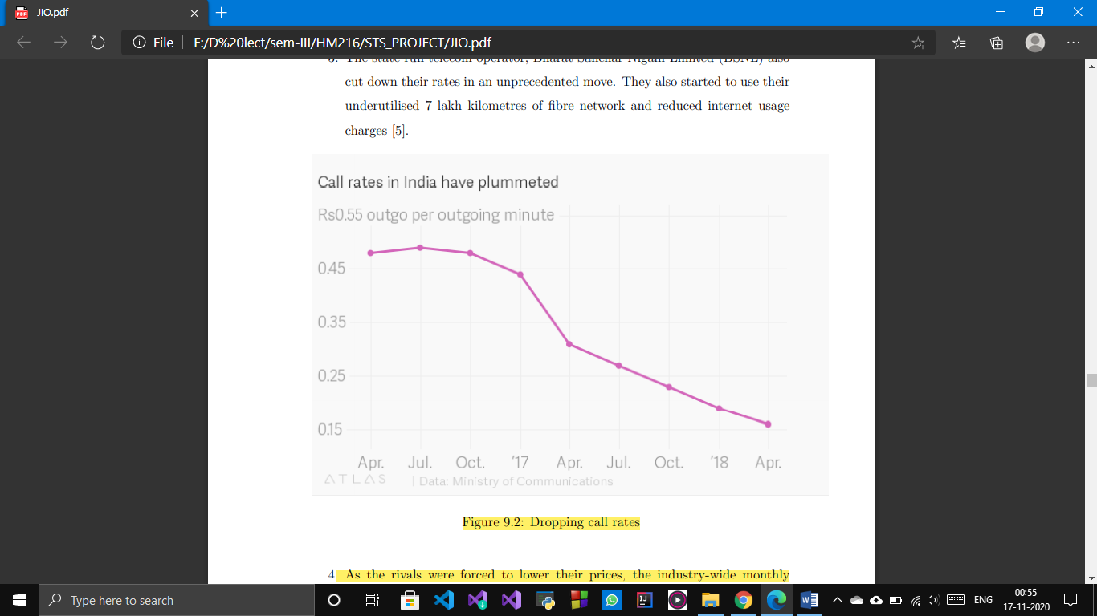

People have become more aware about entertainment, education, shopping, payment and booking etc. As data consumption drastically increased because of extremely low cost of 1 GB data (dropped from 250 Rs per GB to 15 Rs per GB).

From a nationwide survey, 83 % people used data upto 10 GB which after entry of Jio, mobile data consumption of more than 10 GB increased drastically to 383 % and market share from13.7% to 65.2%.

Many government procedures got digitized, leading to decrease in expenditure and time spent over it. Work from home scenarios, online education in schools, colleges during the coronavirus outbreak seemed very difficult to operate without cost effective plans of Jio.

But with pros, cons do come handy. These are not only at competitors at industry level, but also at physical and psychological level of individual who’s a responsible citizen to society and its nation (especially in countries like India where youth forms a major chunk of the population).

Because of data connectivity easily available, people don’t sleep at the time, spend prolonged hours in surfing internet, watching pornography, gambling and other addictive stuff which they shouldn’t be into at this age.

They experience behavioural problems due to over usage of data, unable to control their emotions and the way of thinking.

Physical problems like headaches, sleep disruption etc. Also come in handy.

They increase the net serving time over their set schedule, which also affects the performance of an individual.

Sex addiction through adult chatrooms, cybersex, or pornography on the internet has been a major problem for the young generation who are at a growing age of mental and physical health.

Online gaming for prolonged hours without noting its adverse effects has also been problematic and it also encourages gaming companies to make them even more addicted with luring updates timely.

**Conclusion**

**On the whole, we saw how Jio dominated the Indian telecom market by cutting down tariffs and increasing its customer base with free data offers, voice calls and attractive prepaid plans. They welcomed many new customers to avail of these highly cost-efficient data packs and in all it led to the digital revolution in India where more and more people in rural areas got connected to the internet. It helped India tremendously in these unprecedented times of coronavirus outbreak where work from home or online education has to be done remotely. It also backed many small start-ups towards growth. Students highly benefitted in terms of academic and research purpose and remote access to many e-resources. But has it been fatal for other telecom operators? Obviously yes, they incurred a huge loss as they also had to cut down prices to retain its customer base which led them to huge losses, even some of them reported bankruptcy because of the disruption Jio did in the telecom industry. Vodafone and idea had to merge to survive this throat-cutting competition. Not only companies but society was also affected in some or other way apart from the benefits they got. High mobility of data resulted in a heavy increase of average on-screen time and increased mobility of harmful and addictive data like pornography, violence, cyber-attacks, social abuse etc. It might prove fatal in long run for India where youth population is in majority if such things went out of control and may directly impact social and political growth of the country. Online gaming has risen to a very large extent as many well-known addictive pc games released their mobile version which just required an internet connection to play long hours. This raises a question that will Jio continue to be a forerunner for many decades to come and would they never go down as other companies went on its arrival. Well it might or might not be the same as Bharti Airtel signs deal with one-web in July 2020, claiming to connect every corner of India via a satellite internet connection having low latency and cost-efficient compared to cellular towers. With Jio dominating the telecom market, forced his competitors to think out of box and search for more innovative and cost-efficient approach which was never the case before entry for Jio. In contrary customers have been absolute winners of this healthy competition in the telecom industry, majorly from 2016.**

Acknowledgment

**We would like to express our special thanks of gratitude to Professor Madhumita Mazumdar who gave us the opportunity to work on this wonderful project and for inspiring us.**

**We would also like to thank our TA’s Dushyant Pathak and Anish Pandey for their exemplary guidance, monitoring and constant encouragement throughout the project. We all are really thankful to them.**

**References**

* <https://m.economictimes.com/industry/telecom/telecom-news/the-jio-effect/amp_articleshow/65694564.cms>
* <https://www.newsclick.in/Foreign-Investments-Reliance-Jio-Security-Concern>
* <https://marker.medium.com/how-jio-became-the-darling-of-silicon-valley-4ad5aab7949f>
* :<https://www.qualcomm.com/news/releases/2020/10/20/qualcomm-and-reliance-jio-align-efforts-5g>
* <https://www.statista.com/statistics/901458/india-net-worth-reliance.>
* <https://www.youtube.com/watch?v=VTdVmgtS7e0&ab_channel=Jio>
* <https://www.youtube.com/watch?v=_xPI46FTB-Q&ab_channel=Jio>
* <https://blog.google/around-the-globe/google-asia/bringing-internet-access-millions-more-indians-jio>
* <https://debugger.medium.com/what-is-jio-and-why-are-techs-biggest-players-suddenly-obsessed-with-it-231ea2d407e4>
* <https://yourstory.com/2020/07/jiomart-whatsapp-reliance-retail-mukesh-ambani>
* <https://www.business-standard.com/content/press-releases-ani/reliance-jio-partners-with-usp-studios-strengthening-its-kids-content-play-120100601656_1.html>
* <https://scroll.in/article/965263/how-reliance-industries-cleared-its-21-billion-debt-amid-the-coronavirus-pandemic>
* <https://trai.gov.in/sites/default/files/White_Paper_22022019.pdf>
* <https://www.jio.com/en-in/privacy-policy>
* <https://www.ril.com/OurCompany/ProductsAndBrands.aspx>
* <https://www.statista.com/statistics/255146/number-of-internet-users-in-india/>
* <https://theprint.in/ilanomics/why-modi-govt-has-made-a-good-call-to-move-out-of-all-non-strategic-sectors/478502/>
* <https://www.quora.com/Is-the-privatization-of-PSU-BPCL-encourageable>
* <https://www.thehindu.com/business/Industry/bpcl-privatisation-bid-closes-on-monday-all-eyes-on-reliance/article33102323.ece>
* <https://economictimes.indiatimes.com/topic/PSU-disinvestment>
* <https://www.youtube.com/watch?v=YDvj_WvE2n4>
* <https://www.economicshelp.org/blog/265/economics/are-monopolies-always-bad/>
* [UK, Bharti Enterprises win OneWeb, to spend $1 billion on revival | Business Standard News (business-standard.com)](https://www.business-standard.com/article/companies/uk-bharti-enterprises-win-oneweb-to-spend-1-billion-on-revival-120070301563_1.html)